Create a shoe box theatre

Please see the example from the St Dwynwen’s day assembly.

You will need:

* A shoe box
* Black paint
* A paint brush
* A light or torch
* Some paper puppets
* Craft knife or scissors

What to do:

Step one

Paint the inside of your shoe box. We used acrylic paint but you can use whatever paint you have. It may need a few layers. Put the shoebox in area to dry.



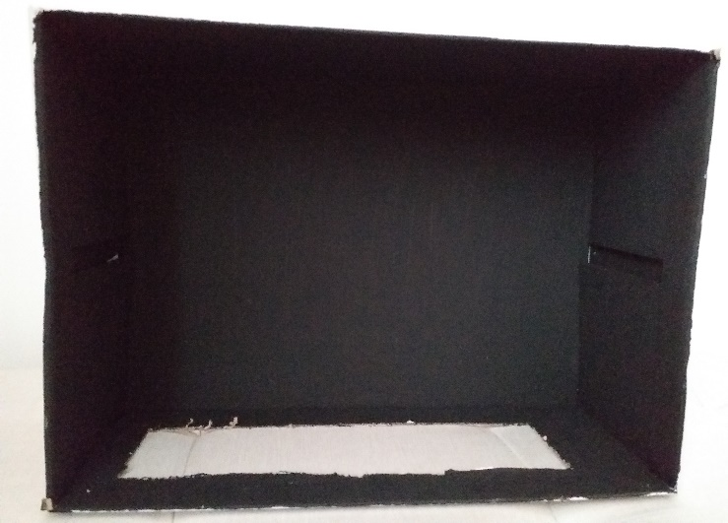

Paint all the inside

Step two

When the paint has dried completely now it’s time to cut out a whole on one side of the box. This will be where the puppets will pop up. It should be around 6cm wide x 25cm long.

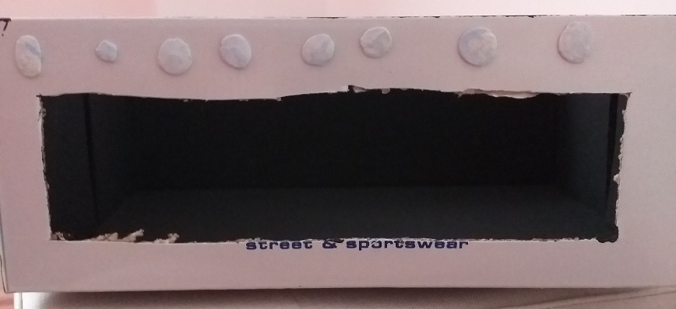

Step three

Prepare any paper puppets that you have or can make. There a some available through twinkl that are free from the homeschooling section.

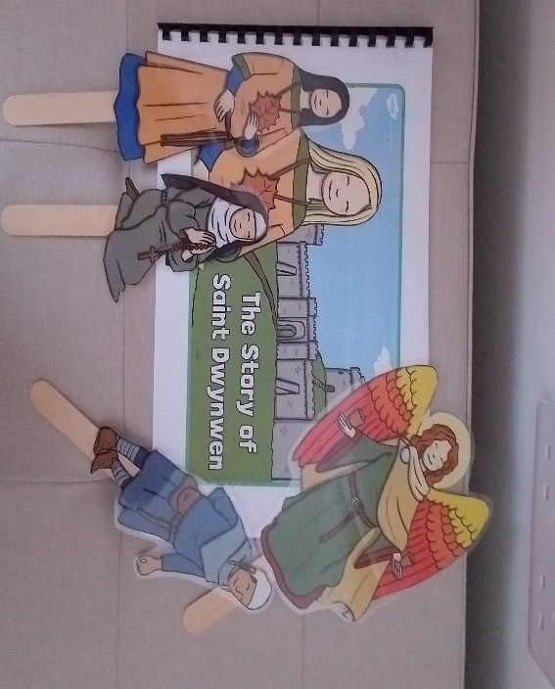

Step three

To add anticipation, use a lamp to shine directly on the shoe box, this help to focus where your child should be looking. You could add some music or sound effects using your phone or other sound source equipment.

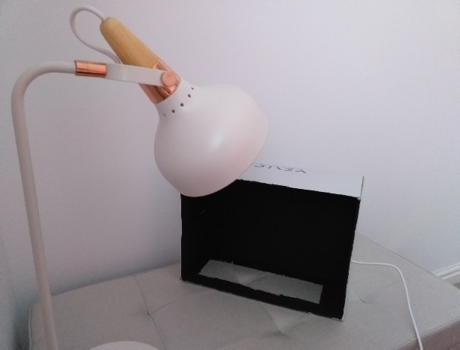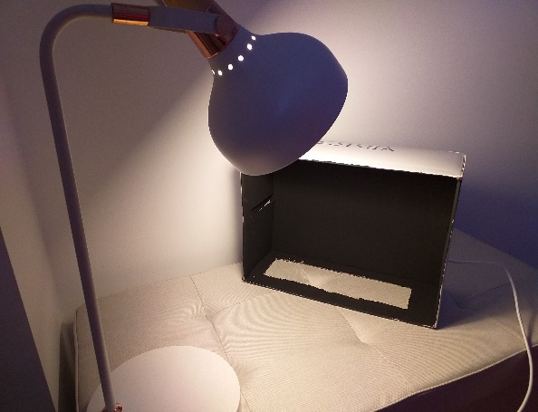

Step four- Have fun!

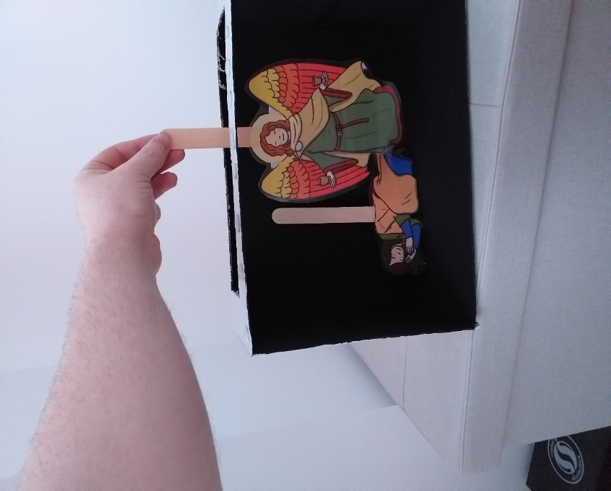

The background really helps the puppets pop!

How does this help?

For any Visually Impaired pupils, the black background helps pupils to focus on the object you want them to see.

It can help with retelling familiar stories. As your child becomes more familiar with the story or song they may want to help by singing the missing word or line.

It can be a way of making puppets of yourself! Cut out heads of yourself from photos and add them to a body. You could have your child involved in this process developing choice making, possibly colours they want to use for their clothes. Or you could use a catalogue of clothes that they could cut out their own outfits.

You could use the puppet show to model behaviours. You may want to recall an incident and perhaps model how you would like your child act next time. It could also offer opportunities to show how people feel when something happens that makes them happy, sad or scared of situations

From a health and wellbeing perspective you could explore feelings with the puppets. Have fun trying silly voices. You could film the puppet show and watch it back together and talk about your favourite parts.

Drama can help with looking at perspectives, feelings and developing empathy or at least an understanding of social interactions. If you use social stories this maybe a way of acting them out.