***Sensory Story-Waves***

***To begin, set your child up with a tray of sand in front of them so they can build up their own beach as the story unfolds. You will need: sand, shells, a smooth piece of wood, a bowl of water, rocks/stones, a feather, a piece of seaweed and a toy fish.***

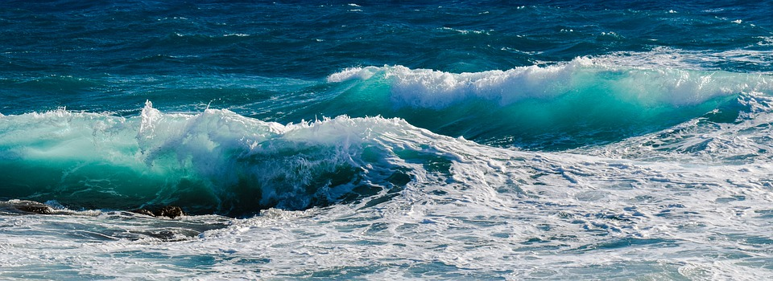

***Hear the waves upon the sand,***

***Feel the water with your hand.***

***(Play the sound of waves crashing on the shore from Youtube. Give your child a bowl of water to play with)***

***Listen to the waves, they dip and swell,***

***Onto the beach they bring a shell !***

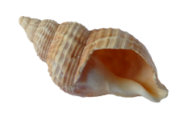

***(Place shells onto the sand in front of your child and encourage them to explore)***

***Playing in the waves is good!***

***Now they bring in some driftwood.***

***(Give them a smooth piece of wood to feel)*** 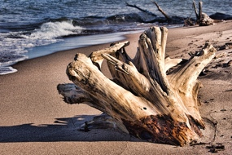

***Paddle with bare feet, never socks!***

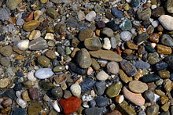***Look the waves bring stones and rocks!***

***(Add the rocks and stones to your child’s beach. Explore together using vocabulary such as heavy/light, rough/smooth and big/small)***

***The waves crash louder have you heard?***

***They bring a feather from a seabird.***

***(Play the sound of the gulls on Youtube. Tickle your child with the feather)***

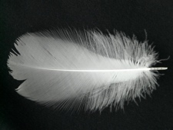

***What else from the waves do we need?***

***A lovely frond of slippery seaweed!***

***(Feel and smell the seaweed then add it to the beach)*** 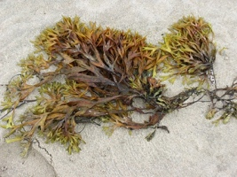

***Lastly, what more could we wish?***

***For our supper a lovely fish!***

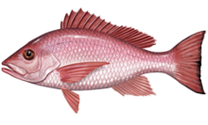***(Allow your child to play with the fish in a bowl of water. This story could be linked to the recipe for fish cakes in the Cookery folder for your child to taste fish)***

***The End***