**Will it float or will it sink?**

**(Science : Materials and their properties week 2)**

## **Low-prep activity for indoors or out**

## This is a low-prep activity to do in the garden when the weather is nice. The children can get as wet and wild as they like with it.

Indoors, they can do this activity with a bowl on their tray, in the bath or on the floor with a tub or basin filled with water.

## 

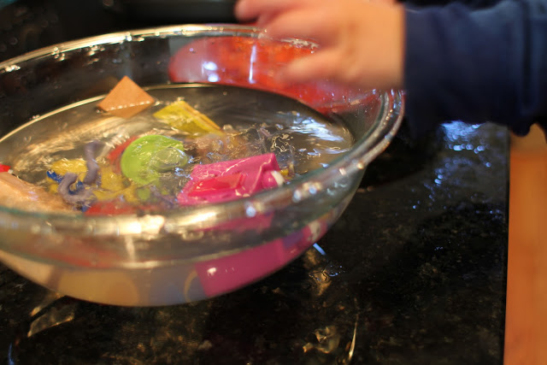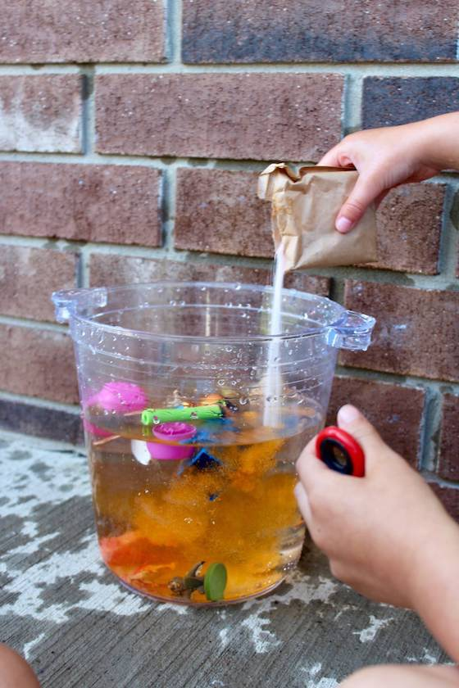

## **Engage their senses with a colourful twist!**

We love adding a packet of jelly crystals to the water. Not only does this colour the water, it gives it a wonderfully fruity scent. Your child should enjoy watching the water change colour, and/or experience the smells of different fruit : children retain more information when more than one sense is engaged.

## **Suggested items for a sink or float experiment:**

### **items that sink**

* metal utensils
* coins
* stones
* toy car/truck
* keys
* glass gemstones or marbles (not suitable for toddlers)

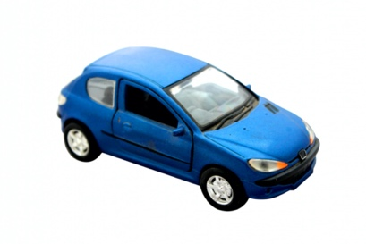 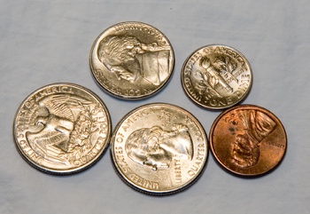 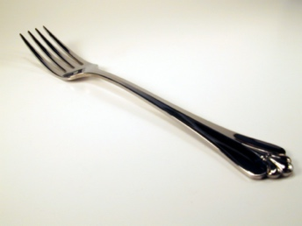

### **ITEMS THAT FLOAT**

* Duplo/Lego
* stick or ice lolly stick
* corks
* bathtub toys
* foam shapes
* crayon
* rubber ball

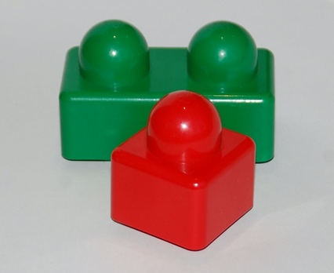 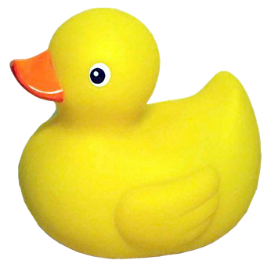 

Now, help them pick up and drop the objects, one by one, into the water and observe their reaction to what happens. Use Science and Maths language such as heavy/light, big/small,float/sink. Describe the materials used such as paper boat, metal fork. If you want to extend the activity or have your child’s siblings or friends joining in then:-

**EXTENSION ACTIVITY**

## **The science behind the sink or float experiment**

Before explaining why items sink or float, ask your children why **they think** an object sinks or floats. They may guess it’s because of size or weight or construction.

Then, explain that **items sink or float based on their density**. Density is determined by how close or far apart molecules are within an item. Molecules are tiny and only visible by a microscope.

Once all of the items are in the water, **you can extend the activity by demonstrating yourself or giving the children drinking straws** to blow the floating items around. This is a fun way to teach children about [kinetic energy](https://inspirationlaboratories.com/k-is-for-kinetic-energy/) as the air they blow through the straw propels the floating items forward.

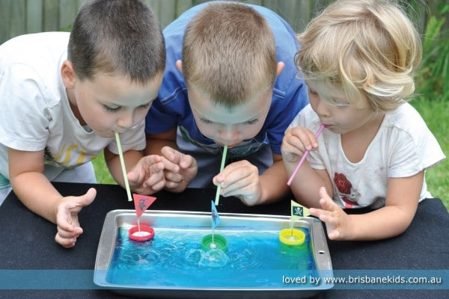

Below is a link to a Youtube video of a child experimenting with floating and sinking objects.

https://www.youtube.com/watch?v=biAwgmDsfXg