**Painting with Pom Poms**

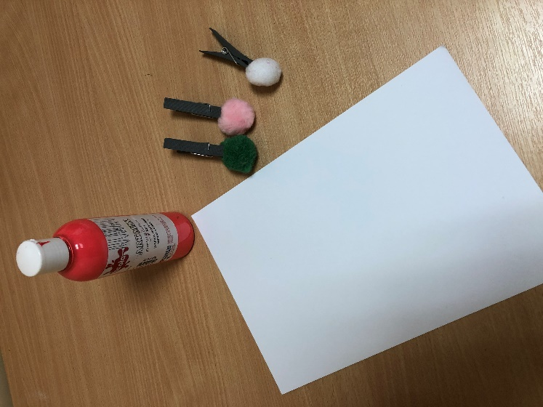

**You will need:**

* Pom poms
* Clothes pegs
* Pink Paint
* Card
* Paint palette or container

**How to make:**

* Attach a clothes peg to your pom pom
* Encourage your child to hold onto the peg to dip their pom pom into the paint
* Encourage your child to decorate their puzzle piece in pink paint by either making dabbing movements or painting with the pom pom.