### **Tissue Box Guitar**

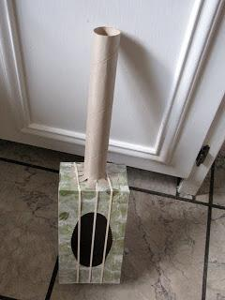

**You will need:**

* Tissue box
* Toilet roll / kitchen roll tube
* Elastic bands
* tape

**How to make:**

* Place the rubber bands around the tissue box so that they lay over the opening.
* Cut one inch slits around one end of the paper towel roll and fold out.
* Tape that end to one of the short sides of the tissue box.
* Strum away!