Simple puppets:

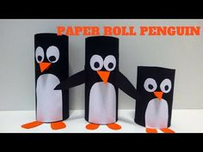 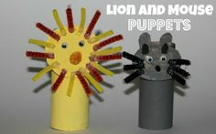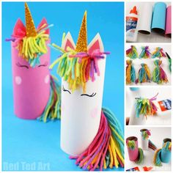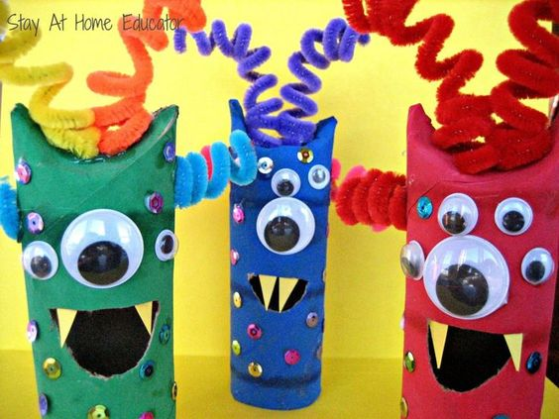

**You will need:**

* Toilet roll tube
* Paint
* Materials of your choice - e.g. coloured paper, felt, googly eyes, feathers

**What to do:**

* Choose what animal you are going to make!
* Decorate your toilet roll tube the colour of your chosen animal - you could either roll in paint, paint with a paint brush or colour in with pens/pencils.
* Decorate your animals features using materials of your choice (e.g. felt, tissue paper, buttons, googly eyes, feathers).

**Dangly puppets:**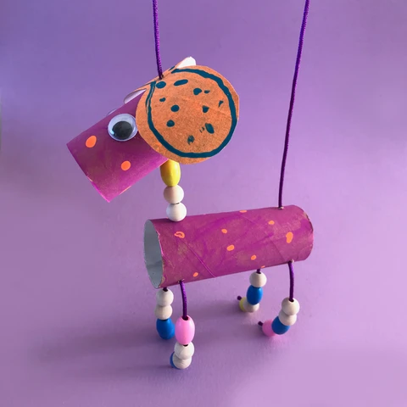

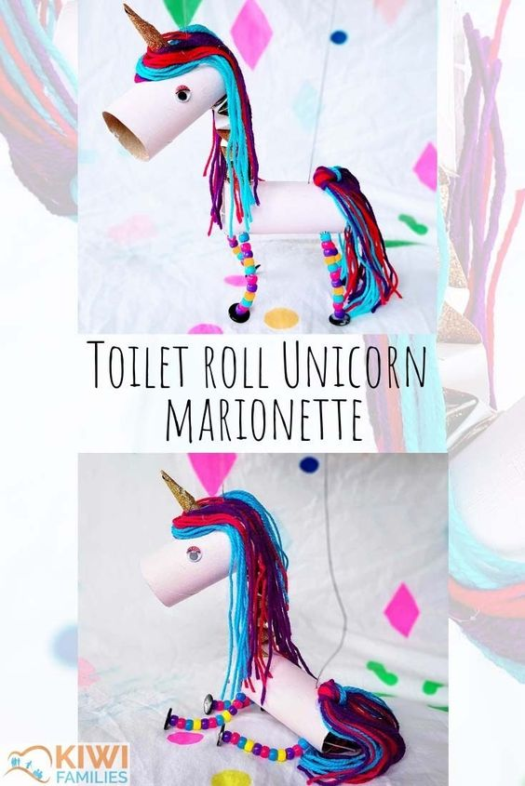

**What you need:**

Toilet rolls

String

Beads

Paint

Scissors

Googly eyes.

Card / wool

**How to make:**

Cut out your ear shapes (if you are making dogs). Paint 2 toilet rolls and your ears.

When your paint is dry, poke 4 holes in the bottom side of your body toilet roll. Then add cord and beads to make your legs knotting the ends of your cord so the beads don't fall off.

Then make 2 holes on the top side of your body tube, one at each end.

Glue your ears onto your head tube, then poke 2 holes through your head.

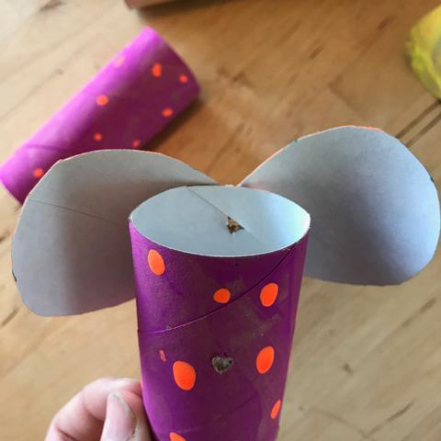

Take a long piece of cord and knot one end. Starting at the head end of your body tube, poke the cord through your hole so the knot is inside the tube. Add some beads to make the neck of your dog. Then poke the cord through the holes in your head tube.

With the end of your cord, poke it through the last hole in the tail end of your body roll and secure with a knot.

Website for dog: <https://minimadthings.com/blogs/news/toilet-roll-puppets>

Website for unicorn: <https://www.kiwifamilies.co.nz/articles/toilet-roll-unicorn-marionette/?utm_medium=social&utm_source=pinterest&utm_campaign=tailwind_tribes&utm_content=tribes&utm_term=684595026_27179146_167602>