**Makaton Signs for ‘Slowly Slowly Sloth’**

**Slowly**

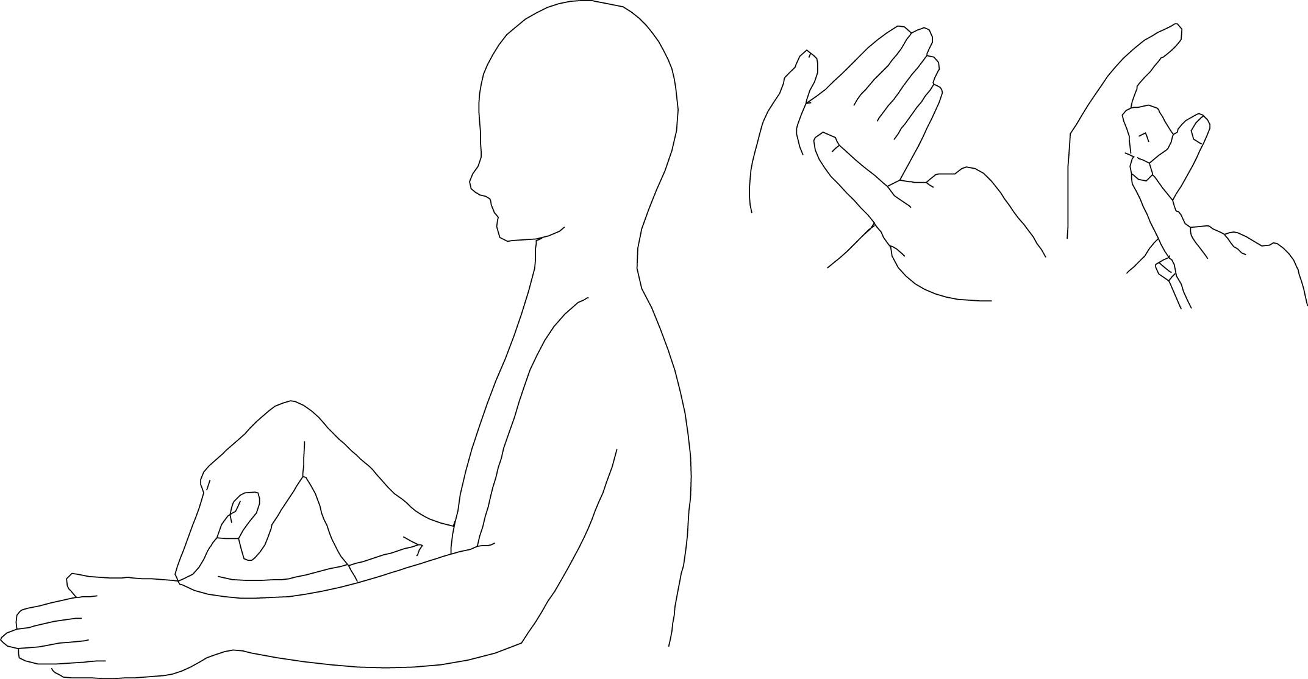

(sign for slow followed by finger spelling ‘L’ and ‘Y’).

**Tree**

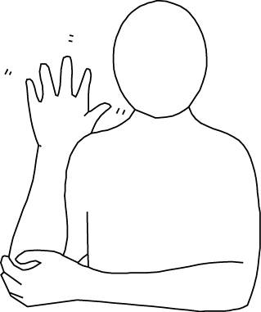

**Ate**

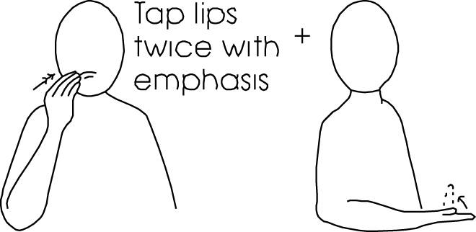

**Leaf**

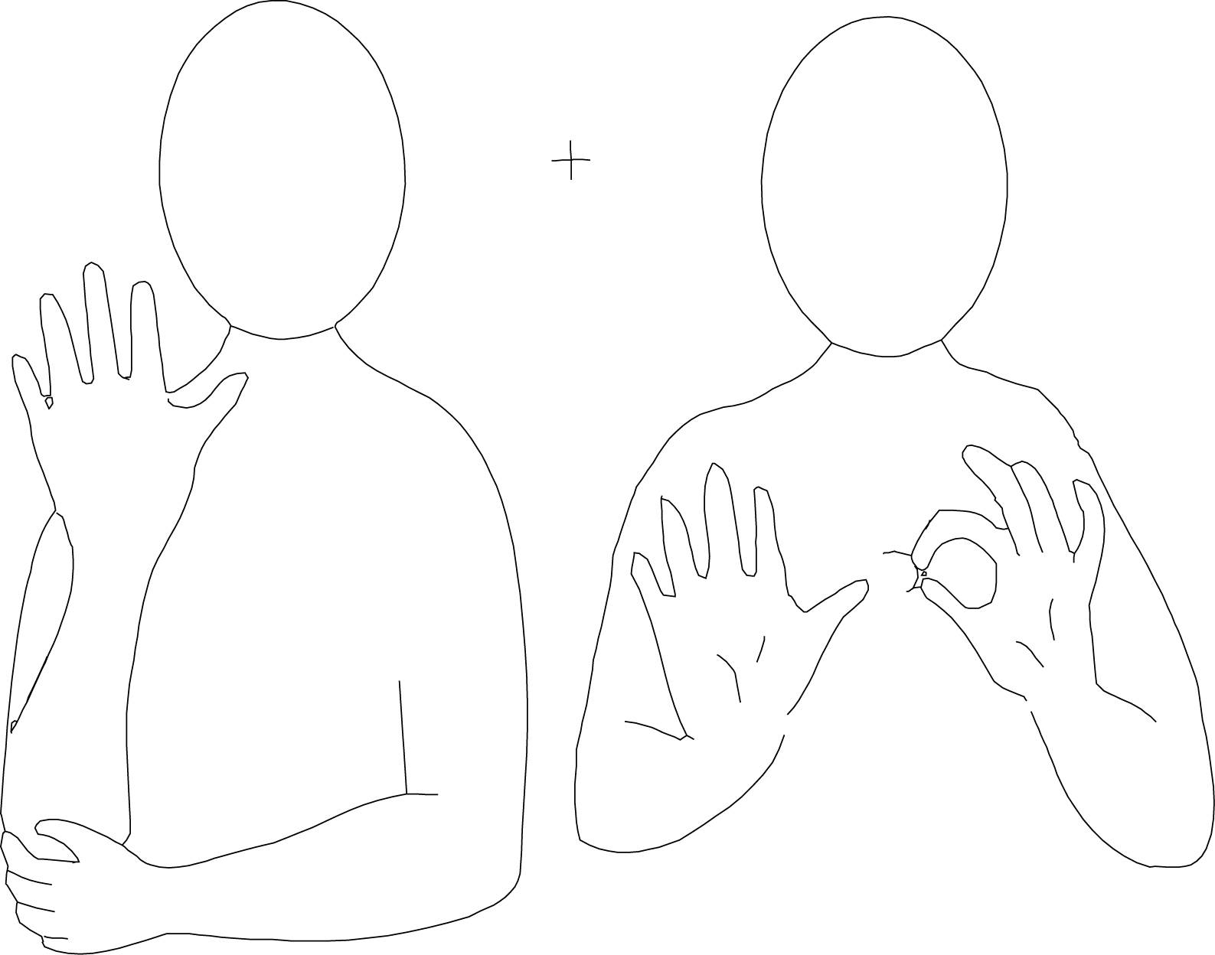

**Asleep**

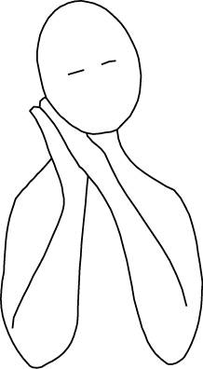

**Awake**

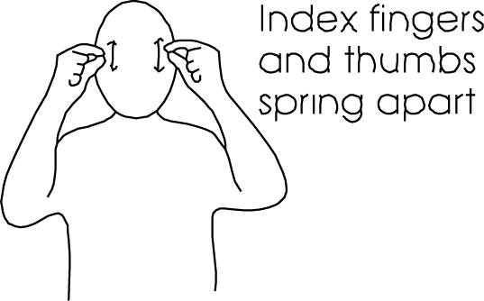

**Day**

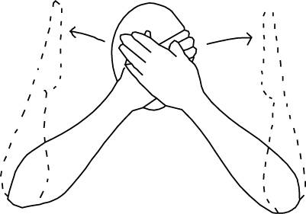

**Night**

