**Art ideas for your puzzle piece.**

**Spray Paint with water bottles**

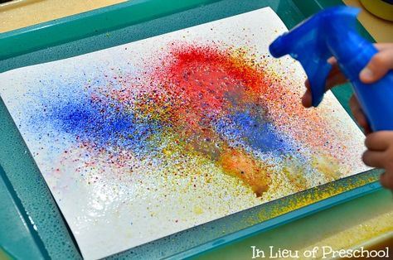

**Splat paint with soap dispenser bottles**:

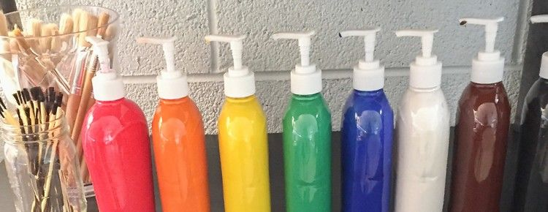

More ideas here!

<https://artfulparent.com/splatter-painting-with-kids-crazy-fun-for-all-ages/>