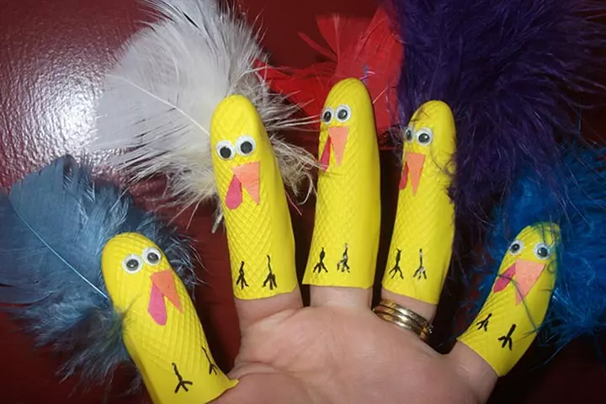

**You will need:**

* Washing up gloves
* Selection of material, for example feathers, felt, googly eyes
* Pens
* Glue
* Scissors

**How to make:**

* Cut the fingers off a rubber washing up glove
* Turn the fingers into any animal of your choice! Decorate them with a selection of materials or colour with pens (see above picture for an idea!).