**Dosbarth Eirlys Sports day 2020**

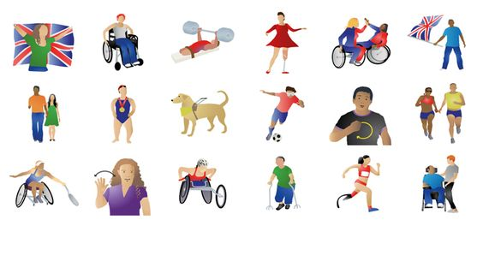

It’s that time of year again where we have lots of celebrations supporting each other whilst we have fun taking part in Ty Gwyn’s sports Day. Why not put your colourful top on of your choice and hopefully have fun and take part. You could do the obstacle courses in your garden or even at the local park if you don’t have space within your home. Why not get the family involved brothers, sisters, mum, dad and even nana make sports day a lot more fun.

**What you will need for each obstacle:**

1.egg and spoon

2.ball and a object (toy garden ornament)

3.Bubbles

4.cones/small objects to run around

5.water balloons/target board (templated included)

6.parachute/sheet/towel and a ball

7. A timer (stopwatch) to time some of the activities

8. A recording sheet (template included)

Obstacle 1-

Find a starting point and ending point it (can be from the back door to the end of the garden). Place you egg onto your spoon, don’t let it fall off, the adult will need to push the child to the finish line. Record how long it took without the egg falling off if the egg falls you must start again whilst the timer keeps going!

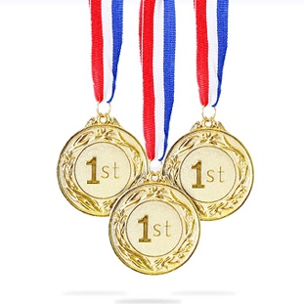Obstacle 2-

On this course place your object (garden ornament/toy) somewhere in the garden where the child will be able to access it with the ball. You will need to roll the ball from the child’s lap 3 times. The best roll will be the one that gets the closet to the object (garden ornament/toy). Mark down out of 3 which roll was the best.

Obstacle 3-

This time you can relax a little bit. You need to put 2 minutes on your stopwatch and pop as many bubbles as you can within them 2 minutes. Can you help you child by counting the number of bubbles you popped and record the score.

Can you beat you team mates? Remember it is about having lots of fun.

Obstacle 4-

Place 4 cones/objects spaced out in the garden. You will need to help your child go through the cones and come back to where you started. Remember to go through each cone and no cheating, again time how long it takes you and record it.

Obstacle 5-

Let’s have fun on this one. Fill you water balloons (or normal balloons with only a little bit of water) if you want colour add a bit of food colouring or paint to get even more messy. Pin up the target sheet. From a distant throw your filled balloons at the target sheet and record your child’s score, roughly use the numbers he\she has hit.

Obstacle 6-

Time to unwind after a busy sports day. Now use a parachute/ towel or a sheet place a ball in the middle. You will need some help from the family to hold sheet. Once the ball is placed on top of the parachute wave it trying to keep the ball onto the parachute. You can do this activity until you.ve had enough.

Well done everyone for taking part. I hope you had lots of fun playing with the family and showing off your skills in sports.



**Recording sheet-**

* Put a tick or a cross under each name if they took part od didn’t take part in that obstacle.

|  |  |  |  |  |  |
| --- | --- | --- | --- | --- | --- |
| **NAMES** |  |  |  |  |  |
| **OBSTACLE 1** |  |  |  |  |  |
| **OBSTACLE 2** |  |  |  |  |  |
| **OBSTACLE 3** |  |  |  |  |  |
| **OBSTACLE 4** |  |  |  |  |  |
| **OBSTACLE 5** |  |  |  |  |  |
| **OBSTACLE 6** |  |  |  |  |  |
| **TIME/SCORE** |  |  |  |  |  |

[](https://thumbs.dreamstime.com/z/simple-circle-target-template-bullseye-symbol-simple-circle-target-template-bullseye-symbol-127253320.jpg)You could make your own so it is bigger, you could use a piece of card and paint the red circles. Add in your numbers 1-5 (5 being in the smallest circle)