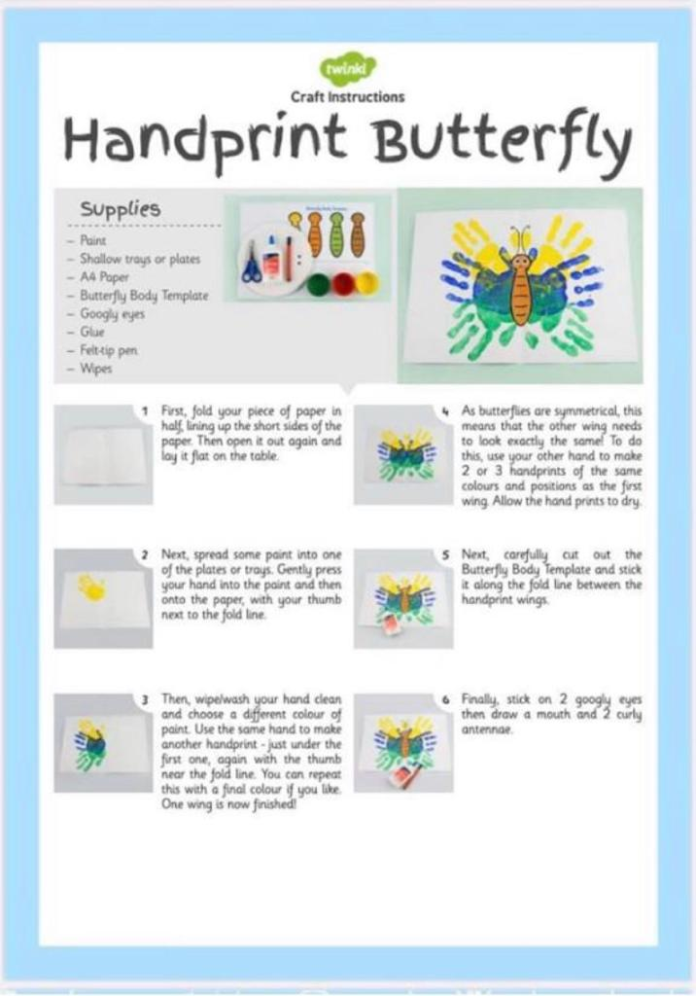

**Materials needed**

* 3 different coloured paints
* White A4 card
* Orange paint
* Blue pen

1. Colour both of your Childs’s hands with one of your chosen colours and place them on the white A4 paper symmetrically.
2. Repeat the above with the other 2 chosen colours.
3. Once the paint has dried draw on the orange body of the caterpillar.
4. Using your blue pen draw the eyes and antennas.