**Tulip Pictures**

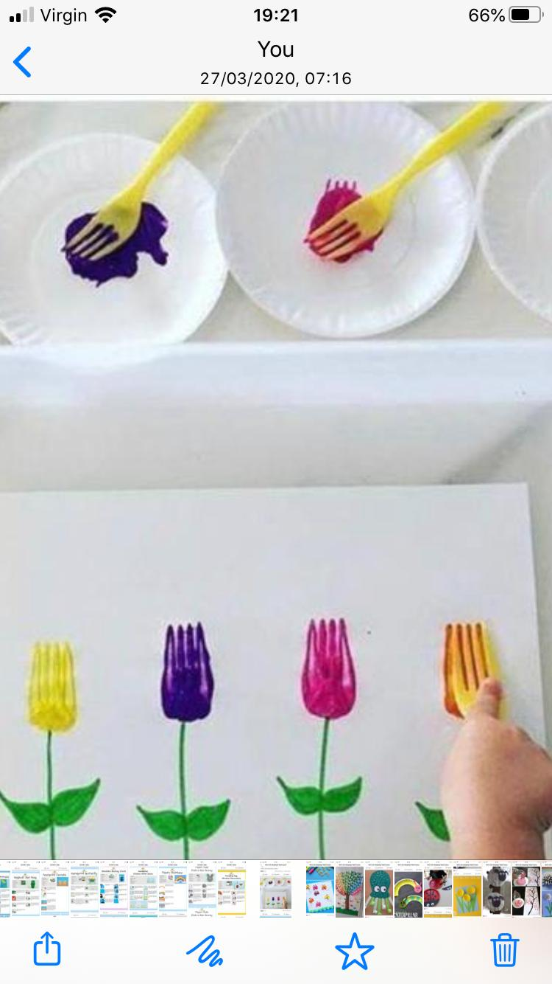

**Materials needed:**

**Paint pallets/paper plates**

**White paper**

**A mixture of coloured paints**

**Fork**

1. **Paint the stems with green paint**
2. **Dip your fork into chosen colour and to create your tulip**
3. **Paint as many as you want to watch your tulip garden grow**